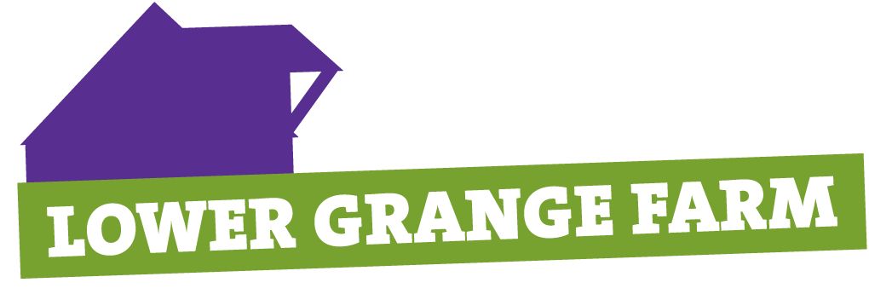
LOWER GRANGE FARM
SCOUT CHALLENGE DAYS
28TH AND 29TH MARCH 2026
JUST FOR SCOUT TROOPS – A BRAND-NEW EVENT AT LOWER GRANGE FARM

Come to Lower Grange Farm with your Troop and join in the Challenge Days organised by the Lower Grange Farm team on Saturday 28th March and Sunday 29th March 2026 – you choose your day. Scouts will be challenged to complete a range of activities from climbing, bouldering, fencing, paddleboarding, quad bikes, mountain biking, rifle shooting, disc golf, pedal cars, cave bus, archery, tomahawk throwing, remote control cars, human table football, remote control boats as well as a whole host of other activities during the session. Participants will get the chance to gain the LGF site badge (included). All are weather and availability dependent. You must book in advance and places are strictly limited so choose your time and date and book quickly to avoid disappointment.

Additional Camping: If you wish to camp as a Troop the night before your Challenge Day, then you can set up from 5pm, but you must be off site by 5pm on the day of your Adventure. There is an additional charge of £2 per head for this (adults are free). You must adhere to the NAN form process. The only facilities available will be toilets and access to water. You must undertake all catering etc yourselves. During the Challenge days the LGF tuck and souvenir shop will be open.

Times: Each day starts at 10am and finishes at 3.30pm with a break for a packed lunch (supplied by the participants).

Capacity: We can accommodate 250 Scouts each day – you must provide a ratio of one adult to every 12 Scouts and adults will be expected to help. We cannot accommodate parents as “spectators” – if they come they must form part of your helper team.

Cost: £20 per young person for the Challenge (Additional £2 for camping). Adults are free! Squash and hot drinks will be provided free of charge during the challenge event.

Bookings: We can only accept bookings from Troops – not from individuals. Please send in the form below to Bunty Ridgway or email bunty.ridgway@kentscouts.org.uk with all the information. Payment by BACS is preferred and you can make this payment using the following details:

Account name Kent County Scout Council Account number 00015563 Sort Code 40 52 40
BACS reference Scout Challenge and your Troop name

When you make the BACS payment please send an email to Bunty and also to finance@kentscouts.org.uk so your payment can be tracked. Places are not guaranteed until full payment is received. If there is any reason why BACS cannot be used for payment you can send one cheque to cover the total cost made payable to KENT COUNTY SCOUT COUNCIL.

You can check availability by sending an email to bunty.ridgway@kentscouts.org.uk or giving her a call on 01634 826759 before booking. Nearer the date you will receive final instructions by email. Please note at this stage you will be sent an Acknowledgement of Risk form for participants to complete and also the necessary permission forms for shooting etc.

Closing Date: 28th February 2026 or before if the event is full.
 ------------------------------------------------------------------------------------------------------------------------------------------------
Return to Bunty Ridgway – LGF Programme Team, 28 Warwick Crescent, Rochester, Kent, ME1 3LF
with either full payment or notification of BACS.

Troop name …………………………………………… District ……………………………………………………

Contact ………………………………………………….. Phone ……………………………………………………

Email ……………………………………………………………
 | Saturday 28th March | Sunday 29th March | Total £
Number of Scouts for Challenge @ £20

Number of Scouts camping overnight at £2
Number of Adults available to help with bases (any permits held)

